Data needed about -

* NPOs about animals
* NPOs for elder people (oldage homes)
* NPOs/orphanages about children’s home
* NPOs/Organizations/shelter homes for homeless

Steps to follow -

1. Clone the GitHub repository:

* Accept the invitation of the GitHub organization CSE-PROJ-2024-09.
* Navigate to <https://github.com/CSE-PROJ-2024-09/Data>
* Click on the code button -

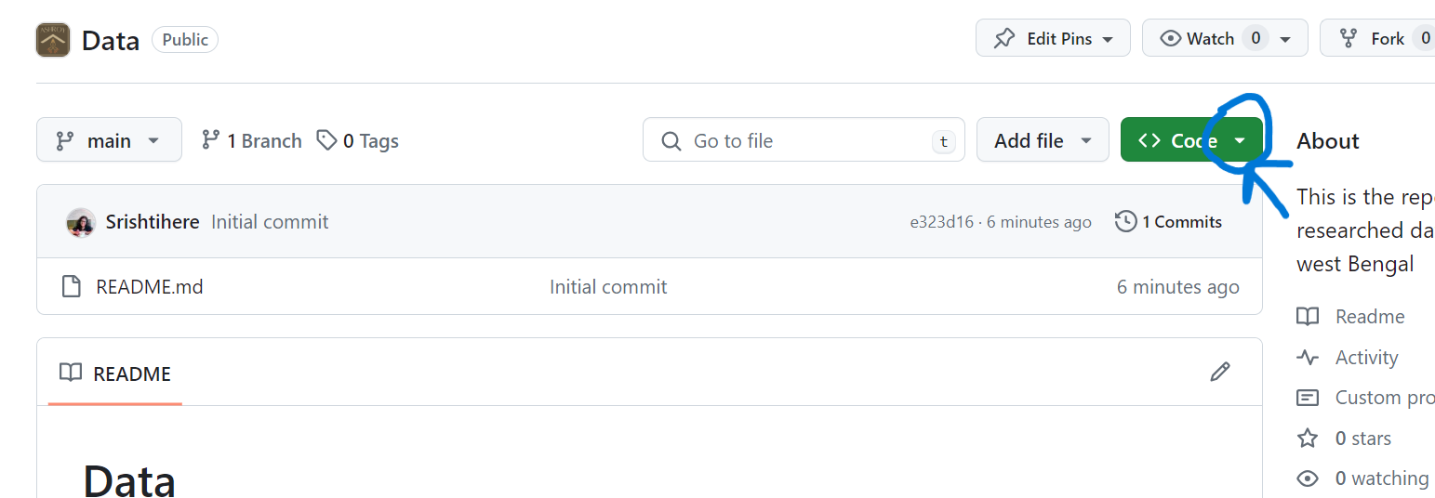

* Then click on the copy button to copy the clone link -

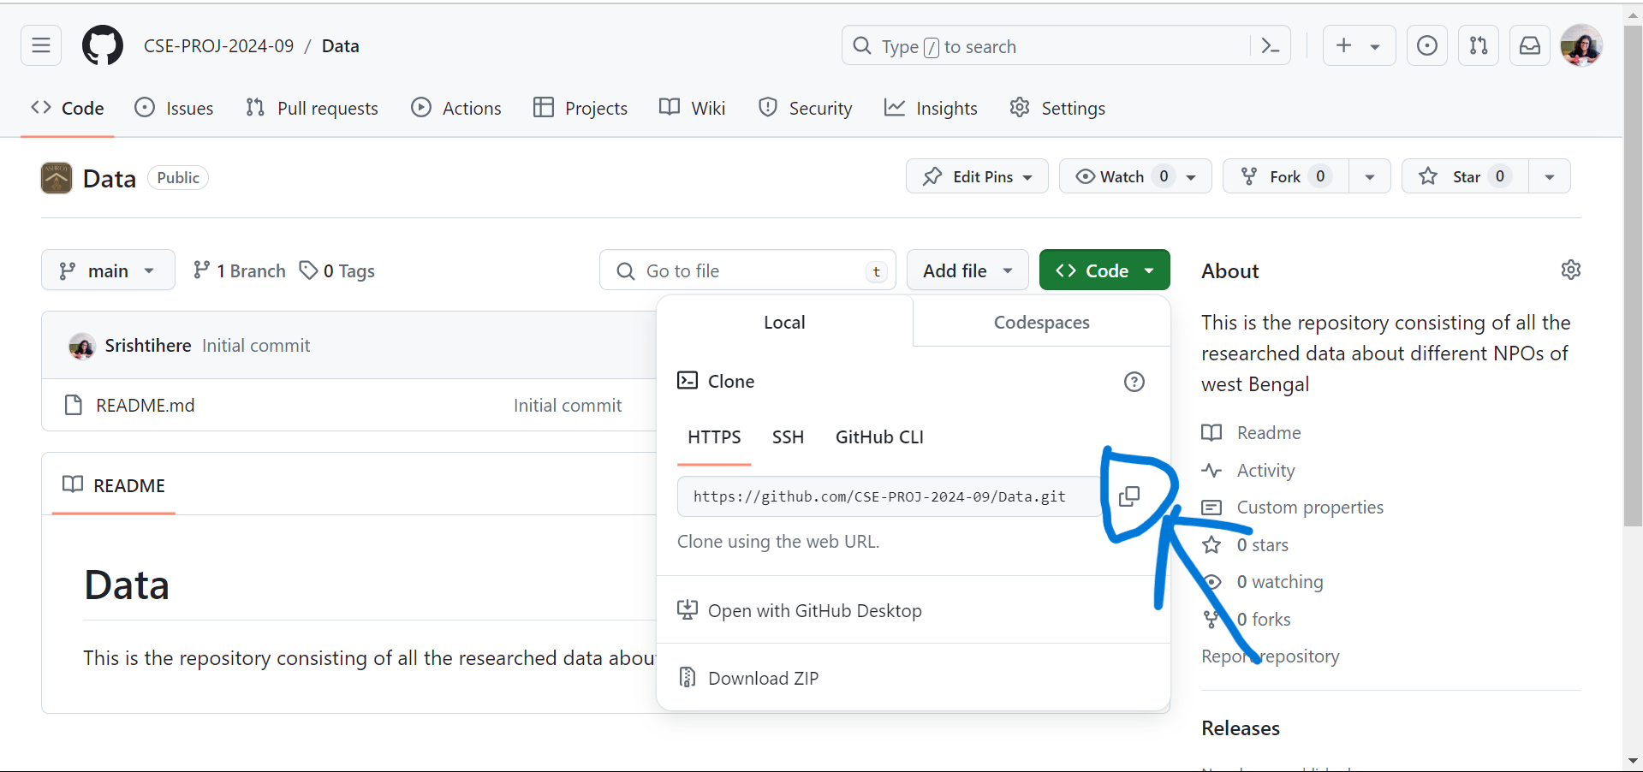

* Go to file manager and your desired location to save the file.
* Right-click and click - **open in terminal** if not present then click on more options and click - **open in terminal**
* Type git clone [ctrl+v /paste the link you copied from github]

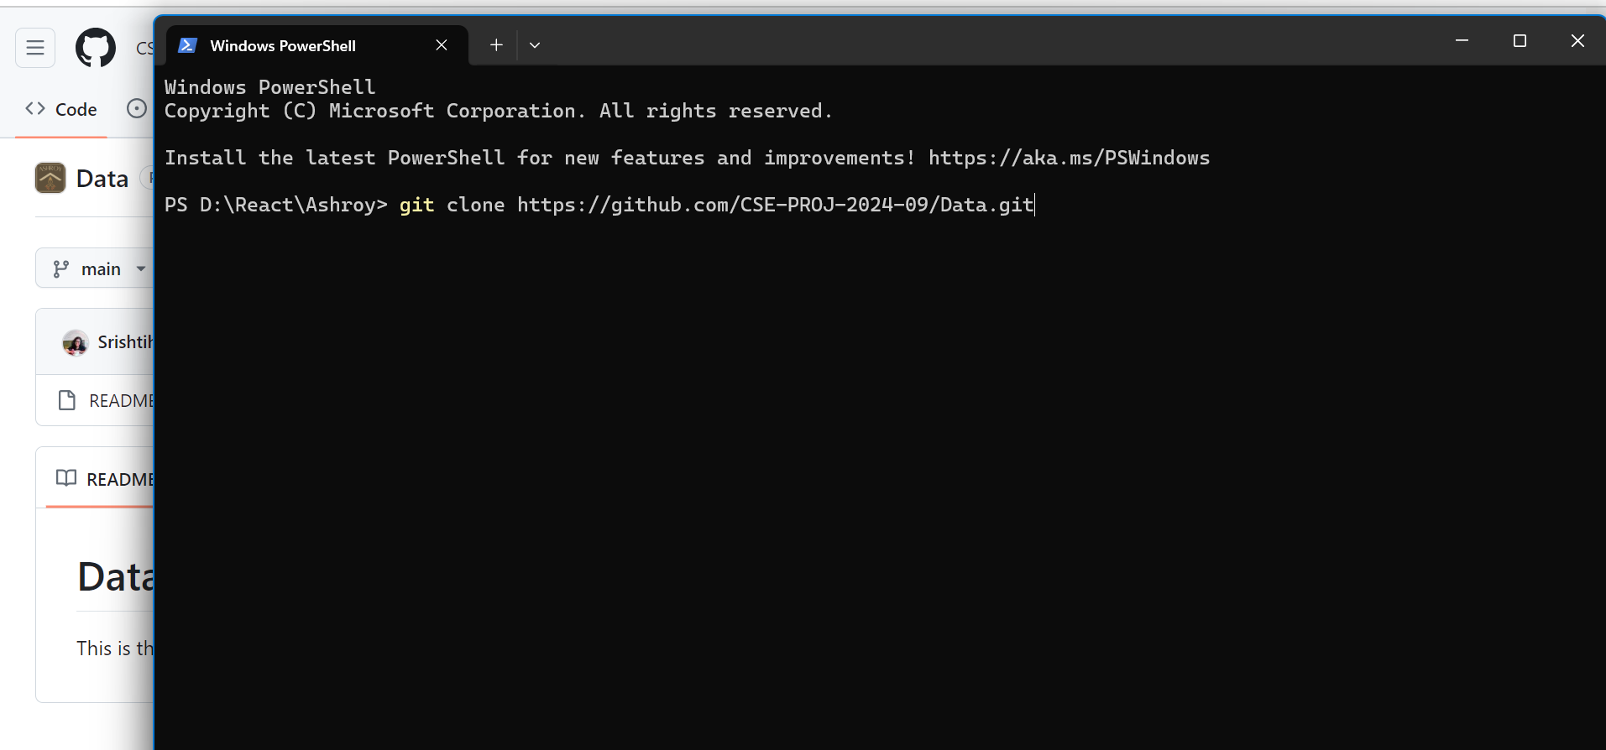

* click enter

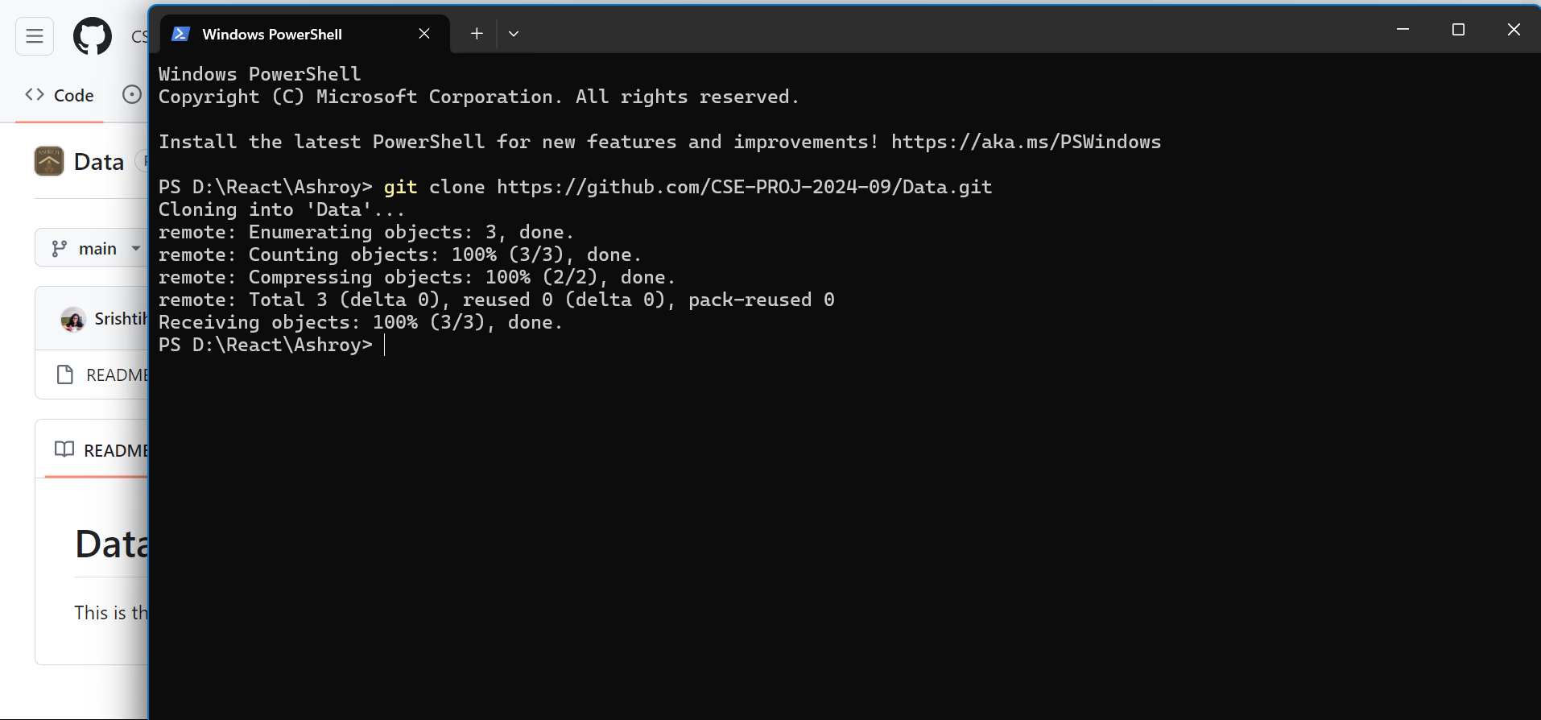

* And you are done

1. Open the Data folder in VSCode (repeat)

* Enter the new folder you just created - Data and right-click and select **Show More Options** and then click **Open with Code.**
* Click on the **new file** option to create a new file in the document.

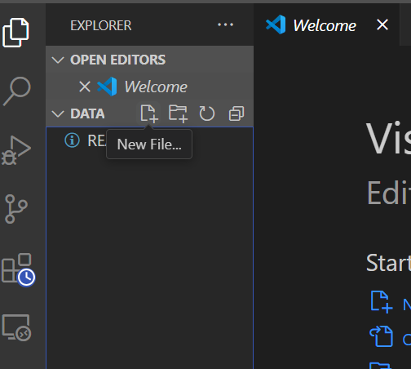

1. Steps to create a JS file and make the structured objects -

* After creating start creating objects in the following format -

{

id: 1,

name: "Animal_welfare_name_string",

Address: "Adsress_string",

Telephone: 123456789,

Website: "link",

image_url: "",

Fcaebook: "",

Instagram: "",

},

You can also ask chatGPT for help with the structure.

* Follow these rules while making the objects -
* Id, name, address, website, tel, and image URL are compulsory.
* Id always has a unique value
* For different types of NPO data, you create, research, and add the most possible attributes(eg:- category, name, subtitle, etc)
* You will not get the value for all the attributes so leave them empty - “ ” if it is a string and 0 is a number.

I have also added one sample file in the Data repository. After cloning you will find the Data.

1. Steps after completion of adding the Data

* Open the command line as mentioned in earlier steps and
* Follow these commands -
* git add .
* git commit -m “data added”
* git push

Follow these steps for now, ask for help from gpt, and if any issue arises contact me.